**Abstract:**

Due to digital transformation, the way of people’s lifestyle has changed significantly during last decades. People are more preferring digital services, rather than traditional services. That’s why business models are changing in order to provide the digital services. Like other industry, Fintech industries are also making progress to accelerate their digital transformation strategies. In this report, a discussion is presented based on an organizational context. The report answers a few important questions about how their business decisions contributed in the digital transformation and business expansion. Also a set of recommendation is proposed based on the answers and current situation of the organization.

**Introduction**:

Digital transformation has been able to largely reshape business strategies and goals throughout industries since it has started to amplify and enhance the quality of services. Innovation and integration of digital solution and infrastructure has made the customer experience more robust and data driven. Customer demand has also been changed. Their preferences are being influenced by these new technologies. They are now preferring digital services over traditional services. That’s why companies are moving towards developing digital transformation strategies in order to reinvent their customer journey, leverage power of data, redefine and build more robust data driven business models. Digital transformation essentially change how a company operates and delivers value to its customers. It also refers to the cultural change that requires the company to continually challenge their status, experiment and get comfortable with failure.

The main concept of digital transformation is to digitize the current form of business and converting the existing strategies to digital solutions. Like every other industry, Fintech organizations are also embarking digitization and by far Alibaba, PayPal and other giants have been able to reshape business models and leverage the barriers of reaching customers beyond borders. They have proved advanced digital concepts and set the standards for the customers. And that’s why to meet customer’s demand it is becoming essential for the business leaders to accommodate and adopt digital solutions. But integrating digital solutions and reshaping legacy business models is challenging. Especially for Fintech companies or banks because they deal with sensitive customer values. In this report, a constructive discussion is presented based on an organization context about their digital transformation strategies, their challenges to reshape business models and expand their newly integrated digital solutions to reach out wide range of customers. The chosen organization is DBS Bank.

The Development Bank (DBS) started their journey in 1968 with goals of operating and providing financial services in Singapore. Since then, throughout its journey it has gone through several vital business decisions and transformations. And as a result the bank has become the largest bank in South Asia by 2015, by serving over four million customers in different countries and regions. Expanding their business beyond the borders of their home market, to new countries and regions, was never easy and they had to face challenges and had to improve their business strategies in order to compete the local and regional competitors. Making right digital transformation strategies and reshaping business models have helped them to overcome these challenges. Because digital transformation strategies are designed to use technology to maximize the business performance and quality of services (Christian Matt et. al., 2015). And also new customers are attracted by tech enhanced services. But business leaders need make the perfect decisions and transformation of their existing structure.

In this report, a discussion about their major strategies to embark digital transformation based on a case study “Driving Digital Transformation at the DBS Bank”. The report explains how their business goals has been changed over time by making progress in their functional operations in order to overcome difficulties and reshaping their business model. Following that, a recommendation is provided to guide them with future steps to accelerate in their digital transformation strategies.

**Discussion**:

Throughout the operational journey, DBS bank has undergone major business decisions to compete with market standards. Their vision was to become Asia’s number one bank and they wanted to expand their operations and services widely throughout countries like Honk Kong, Taiwan, Indonesia and India (Digibank Editorial, 2020). With that vision, in 2013, DBS took the digitalization agenda more seriously and started developing digital business solutions in order to reach customers beyond the home market and increase the revenue stream. DBS knew that digital banking solution would take their business into the next level. They started promoting emerging technologies building by digital offerings including online remittances, mobile banking, home retailer applications, online account opening and loan application etc. But they needed ideas and strategies to develop the digital solution. And the ideas should not be confined in only Fintech industry, they had to diversify the ideas. So, they started developing digital transformation strategies by promoting their digital banking solution plans to the people inside and outside the industry. Their initial plan was to accumulate the potentials and talents with diverse skills, experiences and expertise, in order to develop more robust digital banking solutions.

One of the initiatives that they took, was to put together all the talents and executives to brainstorm ideas and engage them in developing the solutions by organizing hackathons. Because they wanted to explore their learning events beyond the traditional “conference style” formats by experimenting engagement of leaders, executives, start-ups and talents. The purpose of a hackathon event was to build small teams with these people and generate ideas for a given business challenge, finally develop a solution with initial prototype. DBS organized several hackathons in different countries. And as a result they have managed to attract more than 40 start-ups and gather prototypes of digital solutions that covers different business areas. (Siew Kien Sia, Christina Soh and Peter Weill, 2016) A few of the prototypes were eventually helped to build real life digital solutions. Another purpose of organizing the hackathons was to develop digital mindset among the stakeholders inside the organization. Digital mindset is a key attribute for digital transformation strategies (Appendix A). DBS expected their employees to be more digital savvy, thoughtful and flexible in terms of technology.

Although people became concerned about the post-hackathon situation where these ideas and prototypes need to be implemented in real life scenario and the digital mindset of the employees will boost their productivity. Some experts found that these implementations require complex logistics, resourcing, significant amount of time, support, coordination of internal and external stakeholders to be sustainable and scalable. That’s why it is difficult to leverage the positive energy among the employees after certain time. And also hackathon requires organizing an event which involves a lot of stakeholders to work hard throughout the event. This is costly and expensive as well.

Despite of these opinions, from the learning and experiment perspective, the hackathon program was successful and DBS should take it to the next level. A few points to support this statement is given below.

* Positive feedback: The feedback and outcome from these hackathons were outstanding. Leaders were keen to brainstorm and develop solutions with diverse people from inside and outside the organization.
* Increasing positive energy: There were sessions involved with learning, implementing new methodologies and experimenting with them. People inside the organization were happy to learn and experiment through these sessions.
* Knowledge sharing: The event is a great place to share diverse knowledge and learn more. This knowledge sharing involves senior members as well as skilled young talents. This extends the research opportunities and explores possibilities.
* Networking: Hackathons provide opportunity for people to meet and collaborate to create new links in the medium to long term, beyond the short term focus of the event Also, the potential for hackathons for networking in new spaces, including such as the emerging Culture Hacks (Gerard Briscoe and Catherine Mulligan, 2014). Because it involves people from different industries, cultures and also regions. And as a result DBS found a business strategies to implement in India. They partnered up with other companies to expand and share their business model.
* Developed experimental prototypes: Although prototypes are not sustainable or scalable, but they can offer new ideas and solutions. Also it takes certain amount of efforts to develop and deliver a prototype which increases productivity and positivity.
* Exploring new business horizons: As new ideas are evolving through the events, business idea beyond boundaries can come up. But need more sustainable progress prior to that. An organization like DBS has that kind of mentality and they can make good use of it.
* Brand exposure: They reached more customers and interested people by organizing these hackathons. And this should promote their bank as a brand. They managed to organize in different countries which already exposes their intention as well. Also this events provide new marketing concepts and valuable business skills (Michelle Calco and Ann Veeck, 2015).

With goal to embark digitization and extensive digital transformation strategies by accumulating ideas from different industries, DBS decided to spend more time and money in this digital transformation agenda. They introduced a dedicated unit to accelerate these strategies which was a vital business move. In order to do that, they introduced their Digibank unit in 2015. Introducing a dedicated unit was the best option to accelerate the digital transformation strategies. Because DBS wanted to involve as much resources as possible to perform and involve them in their digital growth. They wanted to expand their business internationally by digital solutions.

To set up this new dedicated unit, there were two options. First, they could establish a different company by staffing diverse employees and the company would serve their purpose as an external support. The company would have a flexible start-up culture with opportunities and dedication only for research and development. Otherwise they could involve their own employees and expand their responsivities in order to develop digital solutions. But there are certain pros and cons for each of the options (as shown in Appendix B) and apparently they are culturally very different.

An external start-up company with diverse talent from outside the Fintech industry will not know the industry from its core, meaning they would not understand properly the main responsibilities and requirements of the bank. And it will burden the core members of DBS to make them understand it. And the external people could only develop the product by do research but to implement the model internal people are needed. But an external company will have opportunity for extensive research and development in diverse field. Because the start-up culture has more flexibility and room to progress forward. That always accelerates productivity.

Internal people in the bank would not want to be involved in vast research and development process as developing digital transformation strategies require extensive research in diverse fields. Also they need to invest time in order to make breakthrough. And the corporate culture is not that flexible and progressive as the start-up culture. But internal people would have the knowledge and they know the industry’s requirements from inside. That is their plus point and they could use the end product better than the external people.

That’s why The Digibank unit was created by staffing both internal and external people with diverse skillset in order to maximize their productivity as well as to accelerate faster towards digital transformation (Michael Fitzgerald, 2013). But merging two different culture was challenging and they had to diversify their cultures. And that actually promoted their work environment and they managed to hire diverse skilled people all over the world. Which eventually influenced and worked as productivity boost for the employees who are working in Digibank. That’s why it was the best decision to set up a dedicated unit. And after setting up the unit, the company started rolling out their business outside their region. They had studied and developed different business models according to the regional context. The requirements and demands of the customers as well as the feasibility of current services. They tried to adapt the digital equipment as much as possible. The bank expanded to India.

The implemented different approaches to develop their business model in India than the business model in home market (shown in Appendix C). They focused fully on their digital banking solution as they wanted to enter the market by the involvement of Digibank. And how to enhance their services by accommodating more technologies and data driven tools. The main difference of the business modes was they tried to expand their services by partnering companies in India. They partnered with different local companies to reach out the customers as well as to compete with the local competitors. As they wanted to be digitally involved with the market, they had to make connections through these partners. Because the partners know the market already and they could use their knowledge to get in the business. Whereas their home market was familiar and they had full supports from the customers. That’s why the business model was slightly different. But the core concept was similar that they want to expand their services and take part in digital transformation. And they wanted to meet the customer’s requirements. They involved their partners to survey the customer’s needs in India whereas they did it by themselves in the home market.

There has been a significant impact of emerging technologies so far in the organizational context (shown in Appendix D). Because of digitization they can now gather customer requirements and analyze their data. Emerging technologies has contributed in their mobile and internet banking. They have implemented virtual assistants which is an AI product that enhanced their customer services. Also e-Banking and e-wallet provided secure and cashless transactions. Online websites and platforms automated the business processes like loan applications, account creations.

With the vision of digitalization, DBS should continue to explore their boundaries beyond certain industry. They should design a proper road map to advance their digital transformation in future (shown in Appendix E). A few recommendations for them for them on how the should take the next steps are pointed out below.

* They should try to implement and develop the ideas from the hackathon as sustainable products. They should enhance opportunities in research and development sectors.
* In order to that, they should make scalable project plans, hire sophisticated employees.
* They should spend time and money in research and development of digital solutions.
* Promote and leverage using emerging technologies in research and development
* They should focus more on virtualizing their services. It will expand their services by eradicating the dependencies.
* More diverse and data driven solutions should be implemented.
* Data driven solutions can provide better analytics and insights which will summarize the customer’s demands and requirements.
* They should use these data driven analytics and implement artificial intelligence to improve their customer services. This will also reduce their cost in terms of time and also money.
* They should organize more events like hackathons, seminars and conferences. These are options for networking and knowledge sharing.
* They can hire experts and consultants from research industry, universities to identify the possibilities
* They should explore rural areas as well to deliver their services with digital solutions.
* They should partnered up with more tech and digital companies. This will expand their knowledge and idea for digital solutions.

**Conclusion**:

As the world is moving towards digital transformation, old business models are getting disrupted and new models are introducing day by day. It is business leader’s responsibility to accommodate and adopt digital business models. Because to survive in the competitive market, it is essential to embark the digital transformation. Also Customer’s demand and requirements are influenced and they prefer digital solution. And due to the significant contribution of technology, now the scope of business is not confined in a particular area or country or region. It is now easy to reach customers around the glove. The leaders should think about expanding their business virtually or digitally. But to do that, companies should pay more in research and development of digital solutions, explore the possibilities and functionalities on the digital platforms. They also need to make strategies in order to make progress in digital transformation by scalable and sustainable development plans.

**References**:

Christian Matt, Thomas Hess and Alexander Benlian. 2015. Digital Transformation Strategies. In *Business*

*& Information Systems Engineering volume 57, pages339–343(2015).*

Digibank Editorial. 2020. About Digibank. Available Online:

[https://www.dbs.com/digibank/about-](https://www.dbs.com/digibank/about-             digibank.html)

[digibank.html](https://www.dbs.com/digibank/about-             digibank.html).

Gerard Briscoe and Catherine Mulligan. 2014. Digital Innovation: The Hackathon Phenomenon. Available

Online: <https://www.semanticscholar.org/paper/Digital-Innovation%3A-The-Hackathon-Phenomenon-Briscoe/cb8e44ec1bcd6062e5fccafb6837030be334731d>.

Siew Kien Sia, Christina Soh and Peter Weill. 2016. How DBS Bank Pursued a Digital Business Strategy. In

*MIS Quarterly Executive: Vol. 15 : Iss. 2 , Article 4. Available at:* [*https://aisel.aisnet.org/misqe/vol15/iss2/4*](https://aisel.aisnet.org/misqe/vol15/iss2/4)*.*

Michael Fitzgerald. 2013. DBS Bank Pumps Up the Volume on its Technology. In *MIT Sloan Management*

*Review;* *Cambridge Vol. 55, Iss. 2, (Winter 2014): 1-6.*

Michelle Calco and Ann Veeck. 2015. The Markathon: Adapting the Hackathon Model for an

Introductory Marketing Class Project. *In Marketing Education Review, 25:1, 33-38, DOI: 10.1080/10528008.2015.999600.*

**Appendices:**

Appendix A: Attributes of Digital Transformation Strategy

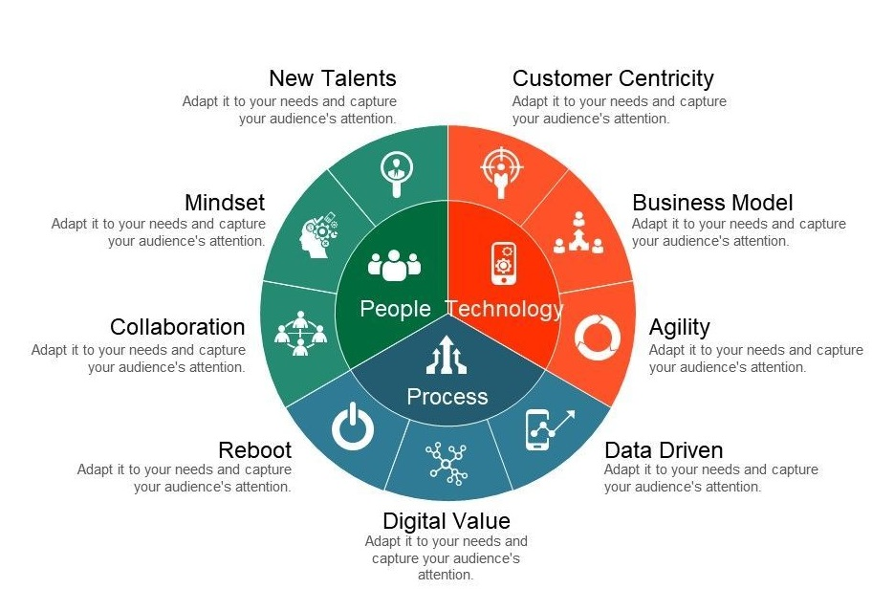

Appendix B: Pros and Cons of External and Internal Business unit

|  |  |
| --- | --- |
| External Unit | Internal Unit |
| |  |  | | --- | --- | | Pros | Cons | | 1. Flexible and progressive environment.  2. More opportunities and room for research and development.  3. Room for diversity. | 1. Less organizational and business knowledge.  2. Lack of business understanding may cost time. | | |  |  | | --- | --- | | Pros | Cons | | 1. Practical knowledge of the business and organization.  2. Business solution would be customer centric and requirement based, but less technical. | 1. Corporate environment which is not flexible and progressive  2. Not much opportunity for research and development.  3. Less diverse. | |

Appendix C: Similarities and differences between business model in India and Home Market

|  |  |
| --- | --- |
| Similarities | Differences |
| 1. Both customer centric and customer demands are the main priority. | 1. Patterned up with local business influencers |
| 1. Both aim to accelerate their digital transformation strategies. | 1. Reach customers with the help of partners. |
| 1. Reach customers by promoting directly |  |

Appendix D: DBS Bank Accommodating Emerging Technologies

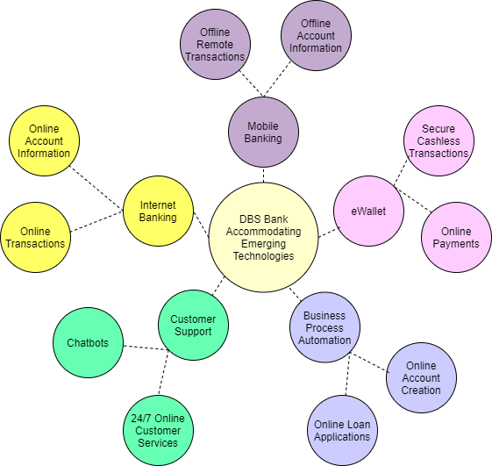

Appendix E: Future Roadmap Guidance to advance Digital Transformation Agenda

